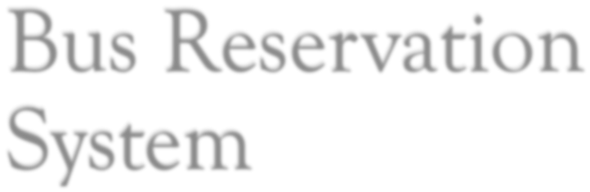



**Contents**

CHAPTER 1: INTRODUCTION 3

1.1 PROJECT BACKGROUND 4

1.2 PROBLEM STATEMENT: 5

1.3PROPOSED SOLUTION: 5

1.4OBJECTIVES: 6

1.5PROJECT JUSTIFICATION: 6

1.6PROJECT SCOPE: 7

1.7PROJECT LIMITATIONS: 7

1.8 BUDGET AND RESOURCES 8

1.9PROJECT SCHEDULE 8

CHAPTER 2: LITERATURE REVIEW 9

**2.1** EXISTING SYSTEMS: 9

2.1.1.Mobile Ticketing (M-Ticketing) 9

2.1.2.SUMMARY AND CONCLUSION 10

CHAPTER 3: SYSTEM ANALYSIS AND REQUIREMENT MODELLING 11

4.1 INTRODUCTION 11

4.2 DESCRIPTION OF THE CURRENT SYSTEM 11

4.2.1 Overview of the current system 11

4.2.2 Problems associated with the current system 12

4.3 SYSTEM REQUIREMENTS 12

4.3.1 Functional requirements 12

4.3.2 Non-functional requirements 13

4.3.3 Domain requirements 14

4.3.4 Database requirements 14

4.4 SYSTEM MODELLING 14

CHAPTER 4: SYSTEM DESIGN 18

5.1 INTRODUCTION 18

5.2 DESCRIPTION OF THE SYSTEM 18

5.2.1 Home page 18

5.2.2 About us page 18

5.2.3 Contacts us and addresses 18

5.2.4 Customer registration 19

5.2.5 User log in 20

5.2.6 Customer booking 20

5.2.7 Administrator log in 21

5.2.8 Administrator update of the booking 21

5.2.9 Administrator update of payment 21

5.3 PHYSICAL PROCESS DEIGN 22

5.4 DATABASE DESIGN 26

5.4.1 Conceptual design 26

5.4.2 Logical Design 28

CHAPTER 5: SYSTEM IMPLEMENTATION 32

6.1 INTRODUCTION 32

6.2 TOOLS USED FOR TESTING 32

6.2.2 Testing tools performance test 32

6.3 SYSTEM TEST PLAN 33

6.4 USER ACCEPTANCE TESTING 33

CHAPTER 7: CONCLUSIONS AND RECOMMENDATIONS 33

7.1 RECOMMENDATIONS 33

7.1.1 Reduction in strictness of the Time deadlines 33

7.1.2 Provision of project finances to the students 34

7.1.3 Compelling some institutions to pave way for the students to develop 34

7.1.4 Future improvements 34

7.2 CONCLUSION 34

REFERENCES ............................................................................................................................. 30

# CHAPTER 1: INTRODUCTION

# 1.1 PROJECT BACKGROUND

This chapter aims to describe the project background, problem statement, objectives, scopes, project significance and expected output of the system. The system is Bus Reservation System. This is the project on the online reservation system of **modern bus company**, which in most cases; the company has problems with their ticketing and scheduling process. This project intends to computerize its semi computerized ticketing system to provide better customer service. Because of that, the company can provide the easier way of travelling to the customer or passenger. Electronic tickets, or e-tickets, give evidence that their holders have permission to enter a place of entertainment, use a means of transportation, or have access to some Internet services. Bus Ticket Reservation System enables the bus company's customer to buy bus ticket online-ticket is the easiest and quickest way to take bus. The online system

LVDQHZV\VWHPEHFDXVHLW¶VMXVWJHWWL

Kenya. Currently, staff at the bus ticket counter is using an internal system to sell ticket at the counter. Customer is unable to buy bus ticket online at this moment and has to go to the counter to buy bus ticket. Sometimes, customer needs to queue up a long queue to buy bus ticket and ask for information. Besides that, customer also not DOORZVEX\LQJEXVWLFNHWWKURXJKWHOHS

always busy. This brings a lot of inconvenience to the customers.

Online Bus Ticket Reservation System enables the customer to buy bus ticket, make payment, cancel reservation and ask for information online easily. Furthermore, staff can sell bus ticket using Bus Ticket Reservation System after check bus ticket availability for the customer and print the bus ticket to the customer that queue up in the counter.

# 1.2 PROBLEM STATEMENT:

The System that is being used by the staff at the counter currently is an internal system and just used to sell the bus ticket at the counter. Customer has to go to the counter to buy bus ticket or ask for bus schedule. Furthermore, customers need to pay cash when they buy the bus ticket and sometimes needs to queue up long time to get the bus ticket. Besides that, customer also not allowed to buy bus ticket through telephone and the bus company's telephone has been always-busy line.

# 1.3PROPOSED SOLUTION:

The solution to this problem is to create an online portal for buying bus ticket system. Customer **can** buy the bus ticket over the Internet, 24 hours a day, 7 **days** a week and the bus ticket can't be lost, stolen or left behind.

In addition, the online system lets the customers check the availability of the bus ticket before they buy bus ticket.

# 1.4OBJECTIVES:

The main objectives of the online system include:

To provide a web-based bus ticket buying functions. Customer can buy bus ticket through the online system and no need to queue up to buy bus ticket at the counter.

To enable customer to check the availability of the bus ticket online.

Customer can check the time departure and arrival for every

7UDQVQDWLRQDO¶VEXVWKURXJKWKHV\VW

To ease the bus ticket payment by online. Customer has to pay the bus ticket by m-pesa money services

To reduce the number of staff at the point of sale. The number of staff at the counter can be reduced after the online buying bus ticket system launch.

# 1.5PROJECT JUSTIFICATION:

As mentioned in the previous section, the online system is just getting its roots in

WKHFRXQWU\¶VWUDQVSRUWV\VWHP,WLV

Company and all. It is important to customer because customer can check

availability of the bus ticket, buy bus ticket, cancel bus ticket and pay the bus ticket online. E-ticket is different with traditional paper ticket because e-ticket is safer, faster, reliable and cheaper. Besides that, this concept can be used by others bus company so that their customers will be satisfied. The profit for the bus company will be increased because the online system will attract more customers and no need to hire many staffs at the counter to sell bus ticket because ticket can be sold efficiency online. Furthermore, the owner can schedule bus roots based on the margin returns. This is done through bus performance comparison. The factors of comparison in this module include but not limited to: the route, operational costs in a particular route and the number of breakdowns per bus

# 1.6PROJECT SCOPE:

The system is web based application. The users will gain access to the available

EXVHVSHUFHUWDLQURXWHDQGDYDLODEOH

portal.

The staff will access the system by logging in via the staff portal where they can compare bus performance and monitor other related business performance issues.

# 1.7PROJECT LIMITATIONS:

User acceptance: some members of the staff may not be of the opinion that the counter system be made online for the fear that this may lead to loss of job.

Computer literacy level: the intended customers may not possess the relevant ICT skills. to benefit from the proposed system. This may cause the company to some costs by offering to train their customers.

Limited system testing: improper unit and system testing may pose some usability issues such as delays in some modules.

# 1.8 BUDGET AND RESOURCES

The budget and the resources for this project have been summarized and tabled (see table 1.0) as shown below.

#### Table 1: Budget and resources

|  |  |
| --- | --- |
| **Resource** | **Cost (Ksh.)** |
| Laptop | 35,000 |
| Flash Disk (8GB) | 1,500 |
| Web browser software | 2,500 |
| Text editor software | 2,000 |
| Travelling | 1,000 |
| Printing | 1,500 |
| Binding | 500 |
| **Total amount** | **44,000** |

# 1.9PROJECT SCHEDULE

This project will comprise all the activities involved in SDLC (see Fig 1). All these activities have been summarized in a Gantt chart below.

|  |  |  |  |  |  |  |  |  |  |  |  |  |  |  |
| --- | --- | --- | --- | --- | --- | --- | --- | --- | --- | --- | --- | --- | --- | --- |
| Weeks activity | 1 | 2 | 3 | 4 | 5 | 6 | 7 | 8 | 9 | 10 | 11 | 12 | 13 | 14 |
| Problem  Definition |  |  |  |  |  |  |  |  |  |  |  |  |  |  |
| Requirement  Identification |  |  |  |  |  |  |  |  |  |  |  |  |  |  |
| Analysis |  |  |  |  |  |  |  |  |  |  |  |  |  |  |
| Design |  |  |  |  |  |  |  |  |  |  |  |  |  |  |
| Implementation testing documenting |  |  |  |  |  |  |  |  |  |  |  |  |  |  |

# CHAPTER 2: LITERATURE REVIEW

# 2.1 EXISTING SYSTEMS:

# 2.1.1.Mobile Ticketing (M-Ticketing)

Mobile ticketing (m-ticketing) can be broadly defined as ordering, purchasing, delivery and usage of a product or service using mobile technology such as Wireless Application Protocol (WAP). The mobile ticketing industry is a relatively recent and up-and-coming portion of the fast-growing e-commerce industry. According to some estimates, approximately 400 million mobile subscribers global networking system will use their mobile phones for ticketing by 2013, with total gross mobile ticketing transactions reaching $92 billion by 2013. The mobile ticketing predictions are being the research domain for several years. M-ticketing permits a customer to purchase a valid and legitimate ticket through mobile phone application. The value added services provided by the application allows users of the mobile ticket to store digital tickets on the phone. By doing so, the consumer is less likely to lose his ticket, ecofriendly, durable, cost effective and paperless.

Generally, the mobile ticketing process can be defined in the following steps :

Registration: Online ticketing requires a company to register with all the business and services information.

Provisioning: Allow mobile phone application to interact with customers, allowing the purchase to take place.

Validation: Validating and legitimate the ticket via electronic validation system between the company and the customer.

Ticket check: Controller to verify and accept the sales and display of the mobile ticket as a valid ticket for the passenger, according to the terms displayed on the ticket.

# 2.1.2.SUMMARY AND CONCLUSION

Indeed, mobile bus ticketing system (MBTS) is the most noteworthy prospects in the world transport system to reduce expenditures and increase traveler's accessibility. This project will reduce ticket processing flow, reduce usage of paper and allows greater convinces and flexibility to the traveler in cities and allow travel agent to make alterations to the journey. There are other important issues from the use of this technique such as the mobile ticket cannot be lost or stolen on the contrary of sending the ticket by mail also there is a probably of sending it to the wrong address. MBTS will make customers' lives easier, and can get the service by himself in anytime, anywhere and any devices.

# CHAPTER 4: SYSTEM ANALYSIS AND REQUIREMENT MODELLING.

# 4.1 INTRODUCTION

In this chapter, the current system used in Modern coast bus ticket booking system is to be examined and the relevant analysis done on it. The core aim of this is to determine whether there is need for a new system or not. The chapter also explains how the current system works by providing system requirements through various models that enables one to comprehend the system better. Modelling tools such as DFDs, flowcharts, use case diagrams and others are used in the chapter.

# 4.2 DESCRIPTION OF THE CURRENT SYSTEM

### 4.2.1 Overview of the current system

Currently, Modern coast bus ticket booking system does not have a particular developed system for enhancing the online booking of bus company. This implies that there is lack of any kind of interaction between the bus company and the customers. In most of time, anyone wishing to do ticket bookinghas to choose from any of the following three options in order to secure a space for service:

1. Visiting the premises of the bus company to make the necessary inquiries upon which booking is done.
2. Contacting the manager in the bus company through a communication channel in order to inquire about the bus company and how booking can be done.
3. Performing consultation from anyone who has ever produced with Modern coast bus ticket booking system or has the knowledge or any relevant information about the bus company.

### 4.2.2 Problems associated with the current system

The main challenge associated with the current system is that potential customers have travel all the way to where the Modern coast bus ticket booking system is located. As a result, there is consumption of time which would be avoided by having an automated system. Booking through a call can limit the provision of enough information which might cause inconveniences of service delivery. All these are both tedious and time consuming activities.

There is also problem of customers being unable to assess the progress of their projects not unless they directly contact the manager which in turn consumes time in both parties.

In some cases, the interested customers may not know exactly where the bus company is located, other than visiting it. This problem is clearly solved by the new system which provides all relevant information about the bus company such as its geographical location, contacts and others.

# 4.3 SYSTEM REQUIREMENTS

So as to be in a position to automate the manual system at Modern coast bus ticket booking system, an automated system was required. This system allows users to perform their booking while in remote environments. Due to this, several requirements were thus required in order to come up with a system that will allow this. Such requirements will be classified into three; functional, non- functional and domain requirements.

### 4.3.1 Functional requirements

These requirements are those that enable the system to operate. These requirements focus mainly on what the system should do. They include:

Users have to register themselves by creating accounts to gain access

WRWKHV\VWHP¶VVHUYLFHV

User authentication by use of password.

The system has two database views; the super administrator has more privileges than the other users. The system shall validate users accessing data in the system through use of password and username validation and verification. A login dialog box will be used for these purposes.

The categories of users allowed to access data in the system are:

i) Administrator, ii)

Customers (clients)

The super Admin will be responsible for making changes to the database while the members will only be allowed to view the contents of the database.

### 4.3.2 Non-functional requirements

These requirements focus on how the system works or how the system should behave by providing its quality attributes. These requirements include:

The system should be able to handle an unlimited number of users at a time.

Documentation: the system will be documented and PDF manuals will be available for users when the system goes live.

Recover-ability: the system will be regularly backed up so that it can be recovered in case data is lost for some reason.

Design constraints: The software will be developed with MySQL database back end.

The system will not work in the absence of internet

The system will only require the registered users to log in to the system.

The system will only allow the super admin to change data on the database and not any other user.

### 4.3.3 Domain requirements

This system will not be in a position to operate in environments which are not accessible to internet

The system will also require the user to have access to a computer/a laptop, a smart phone or any other device that has internet access.

The system will be by those people basic computer skills.

People with visual impairments will not use the system unless there is assistance from people without visual challenges.

### 4.3.4 Database requirements

A common repository of data will be needed. This implies that the new system will require a database for data storage and retrieval for the purposes of processing and feedback information.

The database will require a number of tables to record various entries that the uses will enter into the system.

# 4.4 SYSTEM MODELLING

In this section, diagramming tools are used to help users understand the flow of data for the existing system of operation at Modern coast bus ticket booking system. Since the system is a manual one, below (see Fig 3) is a Data Flow Diagram on how data flows.

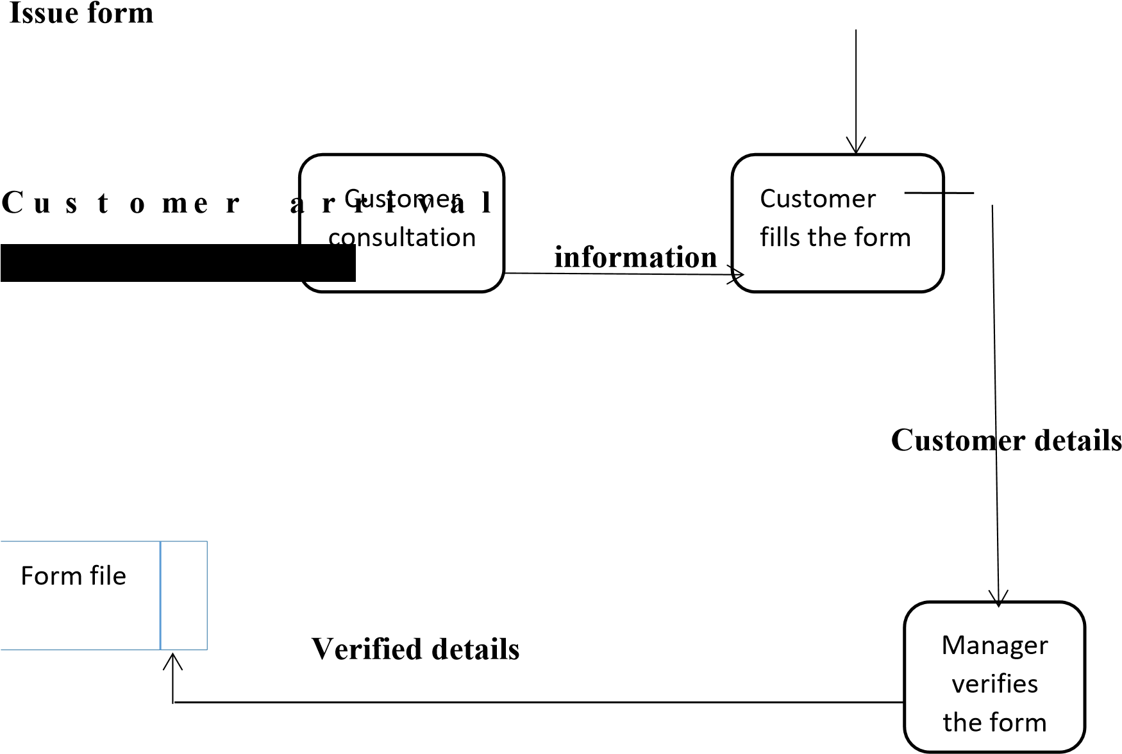

Figure 4 below illustrates the activities that take place with the current system at modern coast bus ticket booking when a client is booking.

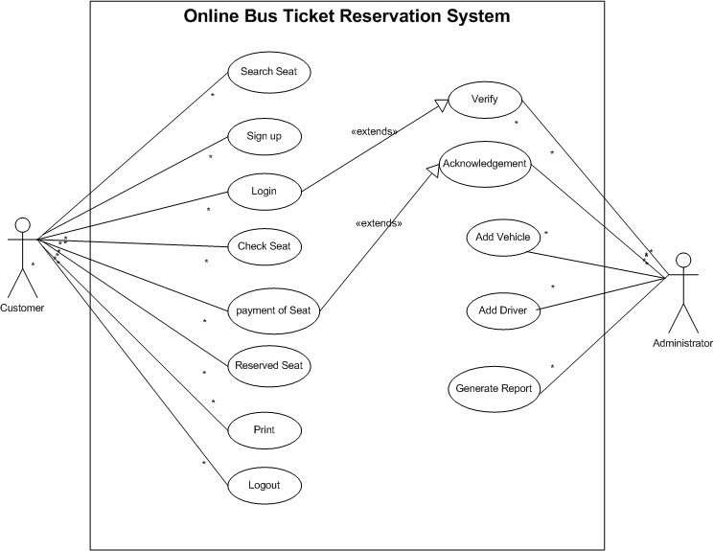



# CHAPTER 5: SYSTEM DESIGN

# 5.1 INTRODUCTION

The aim of this chapter is to examine the system which was proposed for Modern coast bus ticket booking system by describing it in details. It also focuses on the process design of the system which in turn explains how the system operates with the aid of various modeling tools.

0RUHRYHUWKHFKDSWHUIXUWKHUFRYHUVWK both physical, conceptual and logical models. Finally, the chapter will focus on the interface design of the newly proposed system to examine its usability by the users.

# 5.2 DESCRIPTION OF THE SYSTEM

The proposed system will have a structure like the one discussed below.

### 5.2.1 Home page

The system home page is a page where any user lands after typing the address of the site on a web browser. The home page contains general information such as the heading, welcome messages, core values of the bus company, the mission of the bus company and a few images of the bus company. Moreover, there are links to other pages such as log in, register, admin login, services offered, about us and contacts.

### 5.2.2 About us page

This is a page that gives a detailed information about Modern coast bus ticket booking system, what it specializes in and the terms and conditions of producing with them. The page in addition provides the log in and register links to the user for quick navigation purposes.

### 5.2.3 Contacts us and addresses

The contacts page provides all the relevant contact information regarding the location of the bus company, the telephone numbers and the postal addresses of its location. Again, this page provides the register and log in link to direct the user to the appropriate page.

### 5.2.4 Customer registration

In this page, the user is required to create an account with Modern coast bus ticket booking system by filling in a form that is provided. This form contains the following input fields:

First name

The user is required to enter the first name of his/her choice

Last name

The user enters another name different from the first name as the last name

Username

The user provides a name that he/she would be using when logging in into the account.

Email Address

The user is required to provide a valid email address which can be used to communicate

Contact

This is the phone number of the user which might be used to contact the bus company.

Password

This is a secret set of values which can be a mixture of integers, alphabets and other special characters that the user must provide for authentication purposes.

Confirm password.

The user is required to re-type the password to check whether the user is aware of what he/she just typed as the password and also confirm whether there was an error in typing the password.

Register

This is a submit type of input that allows the users to submit their registration details to the server database.

The page again contains the link to log in for quick navigation

### 5.2.5 User log in

This page is an authentication page for those users who claim to have an account with Modern coast bus ticket booking system. It offers a form with only two input fields which include the following:

Username

The user is required to enter the username he/she entered during the account creation form exactly the way it was in that form. Any variation will result to an error.

Password

The user is expected to enter the password that was typed and confirmed during registration/account creation. If the user uses a different password, he/she is told that the password is incorrect.

Login

This is a submit button where the user must click to submit the log in details to the database server. Any variation with the database will result to a log in error.

### 5.2.6 Customer booking

This page is only accessible to users who have registered with Modern coast bus

WLFNHWERRNLQJV\VWHPDQGWKHUHIRUHOHW

offers a booking form which the user must fill in the details. The input fields therefore include:

Category

The user chooses the category of the music presentation which is artist, choir or band.

Location

The location field requires that the user enters the place of residence.

Type of booking

The user must select from the list whether booking is audio, video or audiovisual

Dates of booking

The user should select the dates of actual booking

Time-From-To

This is the time period the booking will take place in the booked date. It provides the time slot.eg 10.00Am-11.00Am

Nature of bus company

Since Modern coast bus ticket booking system can be fixed or mobile, the user is required to check the nature from the two options.

Book

Upon filling in of booking details, the user must click book button which submits the details to the database server.

### 5.2.7 Administrator log in

This page will be used by the system administrator only. He/she will fill in a form with the following input fields:

Username

The admin required to enter the admin username as it is in the admins table. Any variation will result to an error.

3DVVZRUG7KHDGPLQLVH[SHFWHGWRHQ table in the database. Any variation in password will result to admins log in error during submission.

Login

This is a submit button where the admin must click to submit the log in details to the server database table. Any variation with the database will result to a log in error.

### 5.2.8 Administrator update of the booking

:KHQWKHDGPLQORJVLQKHVKHKDVWKH and registration details. The administrator activates all valid bus company bookings

DQG ZLOO LQ WXUQ SRVW WKH SURJUHVV RIrogress view page. In addition, the admin deletes invalid details.

### 5.2.9 Administrator update of payment

In this, the admin verifies the payments by either confirming payments or rejecting.

Any invalid payments are deleted.

# 5.3 PHYSICAL PROCESS DEIGN

In this section, all the processes that take place within the system when a user is using the system are described.

The various processes that take place include: User registration, user log in, user booking, user post payments, user check progress and payments, user log out, admin log in, admin update progress and payments, admin print available bookings, admin post and change bus company prices, admin database manipulation and admin log out.

There are also various storage requirements such as:

User details of registration, User booking details and

Admins authentication details.

The various processes for proposed system in Modern coastsystem have been summarized in a Data Flow Diagram (see figure 5&6). The figure below is therefore a data flow diagram describing the design of these processes: **Customer**

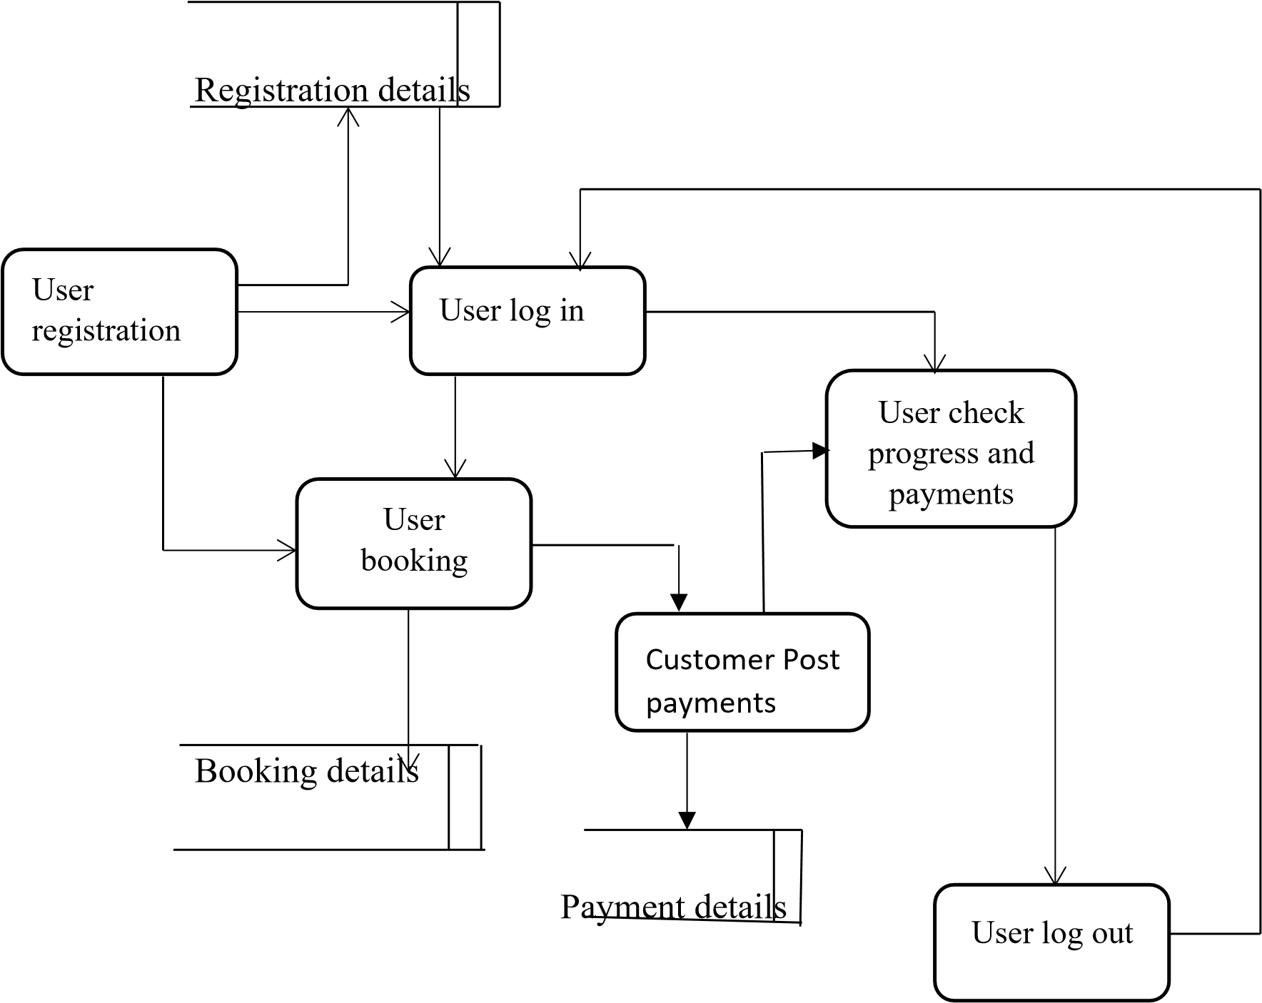

**Administrator**





Login details



Admin log in



Admin update



bookings &



payments



Post &



change bus



company



Admin log



out



Admin



database



The various activities that will be taking place for new system have been summarized using a use case diagram (see figure7). Below therefore shows the use case activity diagram for the new system.



# 5.4 DATABASE DESIGN

The database called customer is designed using the structured query language (SQL) and has following tables:

customers ticket bus destination route timetable

### 5.4.1 Conceptual design

Conceptual design is used to model information gathered from business requirements. Entities and relationships are modeled using ERD and are defined around the business's need. The need of satisfying the database design is not considered yet. Among the design models, conceptual design is the simplest.

This section therefore examines the conceptual database design for the new system at Modern coast bus ticket booking system. The relationship among entities is in figure 8 below;

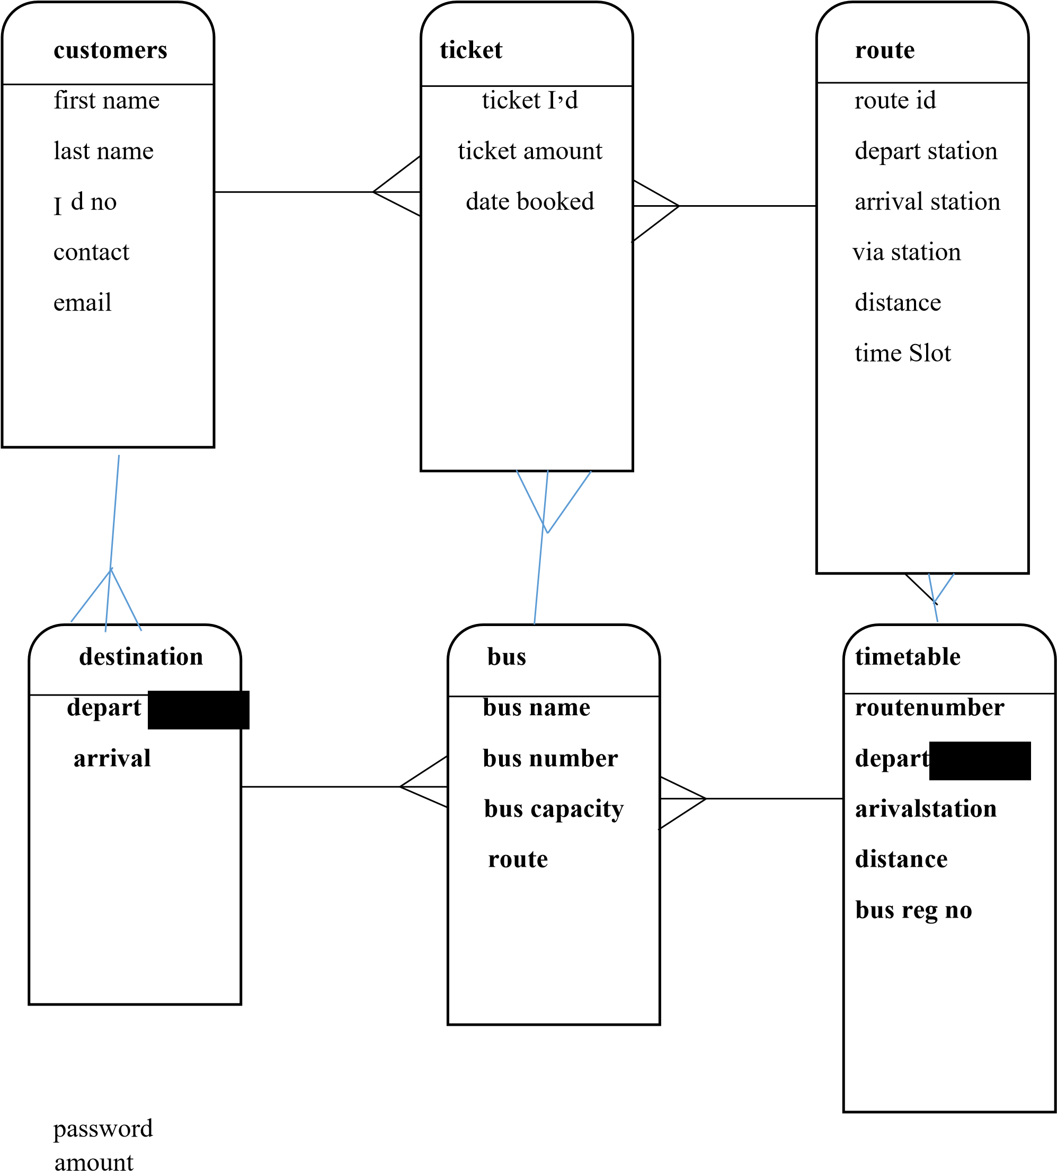

**amount**

### 5.4.2 Logical Design

Description:This table show the activities both a customer and admin can perform once logged in

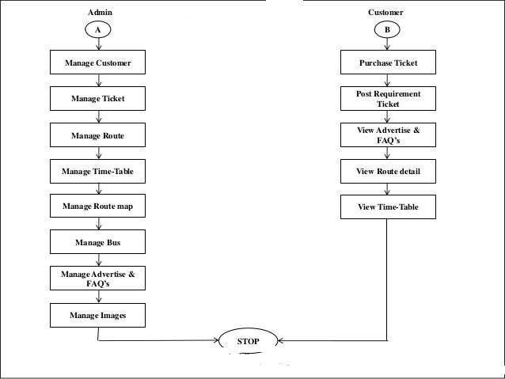

**Description:**This is a data flow diagram tha captures what a user does when searching for a ticket from the website

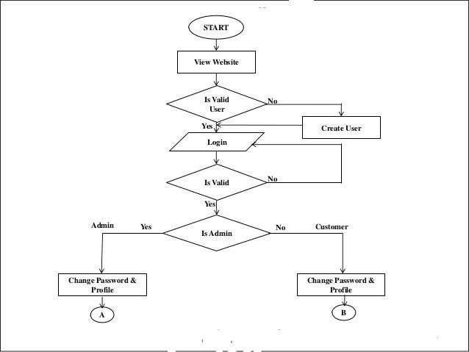

# CHAPTER 6: SYSTEM IMPLEMENTATION

# 6.1 INTRODUCTION

In this chapter, the newly developed system is addressed before it is deployed into the operations of the business. As a result, I am therefore going to examine the tools used for testing, the system test plan, actual testing and finally propose a suitable change over method that the business should employ in order to bring the system into operation.

# 6.2 TOOLS USED FOR TESTING

During the coding process of the entire system, the following tools were of great importance for the project.

## 6.2.1 Testing tools performance test

This test evaluates the working of the system that has been developed to establish whether it is solving the intended problem. Below are the tests that will be used for this system.

**Unit testing:** This requires that testing be done on individual units constituting the entire system. This testing approach was to help identify errors since each unit was examined independently.

**Stress testing:** This is a testing method that always tests the behavior of a system when subjected to unusual conditions. I tested the system with invalid input data such as unfilled input fields and no execution could continue.

**Actual system testing:**

This is done to the entire system to test the general working of the system after it has been fully developed. This test will be done on this system to test whether the objectives stated earlier have been achieved or not.

**Functional testing:**

This involves testing the functions of the program by providing an input data and observing the output. This will be done to test the working of the various functions of the program and any unexpected behavior will be identified and corrected accordingly.

# 6.3 SYSTEM TEST PLAN

The system was tested in all aspects of functionality whereby various types of data inputs such as integers (INT), variable characters (VARCHAR), DATETIME and others were used and the results were observed.

# 6.4 USER ACCEPTANCE TESTING

During the testing process, any invalid data input altered the expected results and the system validation functions could alert the user of these invalid inputs.

The system was also subjected to potential users for feedback and acceptance tests and I got a positive response from these users whereby they accepted the system as a solution to inefficient manual operations in Modern coast bus booking system productions. Acceptance testing was done after the completion of development process where the system was delivered to the users for their views and once they accepted the system, then the system is said to have met the user requirement. User acceptance for this system was be done at later stages of development to give potential users/clients an opportunity to give views about it.

# CHAPTER 7: CONCLUSIONS AND RECOMMENDATIONS

# 7.1 RECOMMENDATIONS

In order to reverse the risks/problems involved in the project and realize improvements in succeeding developments, I would like to make the following recommendations.

### 7.1.1 Reduction in strictness of the Time deadlines

Since some of the issues in this system cover new concepts, I would recommend that the students be allowed to begin the project development at a quite early time to build up on their Ideas and to complete early and meet the set deadlines by the requirements.

### 7.1.2 Provision of project finances to the students

Due to the fact that some of the students are unable to meet the threshold required for data and requirements capture, I would recommend that some special finances be provided to act as the support for the students who face difficulties in the development and research process.

### 7.1.3 Compelling some institutions to pave way for the students to develop

Some institutions have been a major bottleneck in the development of the projects and the higher-level institutions should compel them to release and loosen the restrictions they have over their intellectual property such API (Application Programming Interface).

### 7.1.4 Future improvements

I would like to say that my system did not capture everything that would be required and would therefore recommend for future improvements on the following:

A feature to allow the admin message the clients within the system Features to enable clients give their feedback and suggestions.

Integrating the system with M-pesa for customers to make payments using the system.

# 7.2 CONCLUSION

It is clear that the existing systems of booking are limited to fixed bus company services and do not provide mobile bus company service feature. This is therefore a bit expensive to the clients as compared to when the bus company itself visits the clients who sometimes might be a singing group of 20 members or a band. Therefore, proposed system provides a module to select the nature of the bus company, i.e. either mobile or fixed and this helps the clients make order for the bus company itself to visit them. This will reduce unnecessary costs and time consumption.

The problems associated with the current system will be addressed with the new proposed system. The whole design of the proposed system is a clear automation of the current system at Modern coast bus ticket booking system and therefore the problems associated with the manual system are well addressed by this design.

Also, the new system has been developed with a graphical user interface that is simple for use and is therefore going to simplify the entire booking process. Despite a few challenges in the implementation process, the process was a successful one as I was able to come up with a system that did not only work but also got acceptance form users.

Taking this project all through has been a wonderful experience for me and for the practical knowledge that I acquired, this would not have materialized. This is a very important part of my course and has helped me understand the concepts behind a number of web scripting languages as well as familiarize with the market expectations of the course at large.